# Exercise: CI/CD in GitHub Actions

Problems for exercises for the "[Software Engineering and DevOps](https://softuni.bg/trainings/4333/software-engineering-and-devops-october-2023)" course @ SoftUni.

## CI Workflow – "Student Registry" App

### Step 1: Run the App Locally

We have the "Student Registry" Node.js **app** in the **resources**. Your task is to **create a CI workflow** in GitHub Actions to **start and test the app** on three different Node.js versions:

Let's first **start the app locally** in Visual Studio Code. To do this, you should **open the project**, open a **new terminal** from [Terminal] 🡪 [New Terminal] and **execute** the "npm install" and "npm start" **commands**:

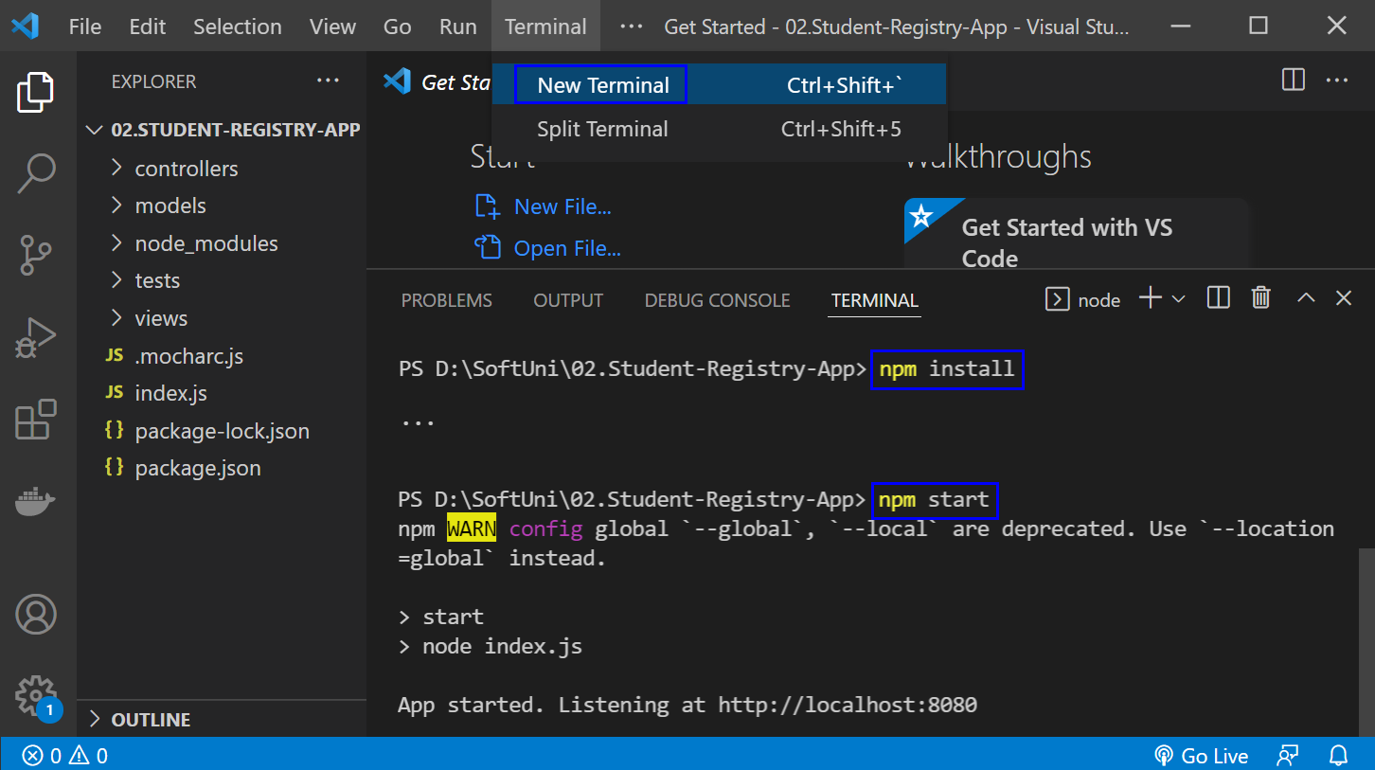

The "npm install" **command** **installs app dependencies** from the package.json **file** and "npm start" **starts the app**. You can **look at the app** on <http://localhost:8080>:

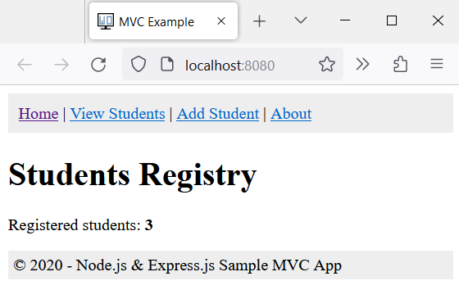

Then, you can **return to** VisualStudioCode, open a **new terminal** with [+] and **run** "npm test" to **run the app tests**. They should be **successful**:

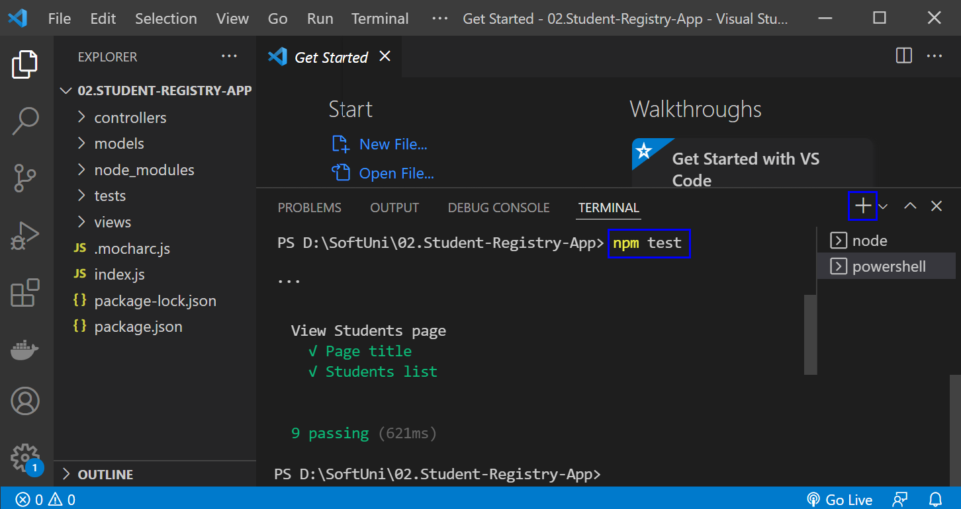

**NOTE**: if the **app was not started**, **tests would fail** because these are integration tests and are executed on the running app.

### Step 2: Create and Run Workflow

Now you should **upload the app code to** GitHub and **create a** GitHubActionsCI **workflow** to **start and test the app**. You can use the **following template**:

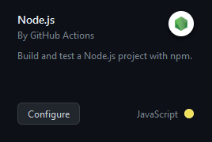

**Before you commit** the **generated** YAML **workflow file**, you should:

* **Change the YAML file name** to something more meaningful
* **Examine the workflow**, the **job** you have and its **steps**
* **Run the job** on the **last Node.js versions**: **18.x**
* **Change the workflow name**
* **Modify workflow job steps**: you should **use the three commands** which we used above to **start and test the app**, not the ones you have in the generated YAML file or **your workflow won't be successful**
* **Add names for each step** in your workflow job

Finally, **run the workflow job** and make sure that **it is successful**:

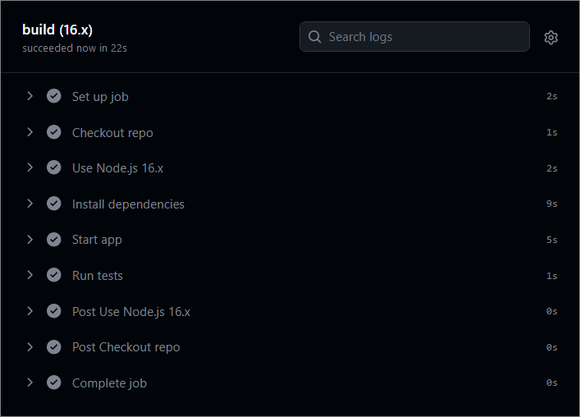

## CD Workflow – "Student Registry" App

Now, let's **create a** CD **workflow** for the "Student Registry" Node.js **app** to **deploy it to** Render.com.

We will continue working on the file that we created for the **CI** workflow.

To do this, you should **fulfill the following steps**:

* Create a free **Render.com account**
* **Generate an API Token:**
  + Navigate to the "**API Keys**" section in your **Render.com** Account settings;
  + Generate an API token by clicking on "**Create API Key**";
  + Give it a meaningful name (e.g., "**GitHub Actions Token**");
  + Click on "**Create Token**" to generate it.
* Add a new **Web Service:**
  + Connect your **GitHub** **account** to the service;
  + Connect your **GitHub** **repository** holding the application;
  + Give your **service a unique** and **meaningful** name;
* Add Render **Service ID as a GitHub Secret**:
  + Go to the **Settings menu** of your web service in Render.com and find the **Deploy Hook**;
  + **Copy the value that matches the pattern from the red square:**

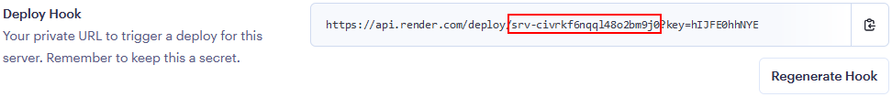

* + Go to your GitHub repository, click on "**Settings**," then select "**Secrets and variables**" from the left sidebar;
  + Click on "**Actions**" and then click on "**New repository secret**" and add a new secret with the following details:
    - Name: **SERVICE_ID**
    - Value: The service id that you copied from Render.com
  + Click "**Add secret**" to save it.
* **Add Render.com API Token as a GitHub Secret:**
  + Go to your GitHub repository, click on "**Settings**," then select "**Secrets and variables**" from the left sidebar;
  + Click on "**Actions**" and then click on "**New repository secret**" and add a new secret with the following details:
    - Name: **RENDER_TOKEN**
    - Value: The API token you generated on Render.com
  + Click "**Add secret**" to save it.
* **Create and define the CD workflow:**
  + Set the **job** to be **dependent** of the **test** job from the **CI workflow**
  + In the **YAML** file that we used for the CI workflow, use the **custom** GitHub action [**johnbeynon/render-deploy-action@v0.0.8**](https://github.com/marketplace/actions/render-deploy-action) to deploy the application to Render;
  + Use the Render service ID and API key, which are stored as secrets in the repository.

GitHub Actions will execute the CD workflow, which involves installing Node.js, installing dependencies, and deploying the app to **Render.com**. The workflow will log in to **Render.com** using the API token you provided as a secret and then deploy your app.

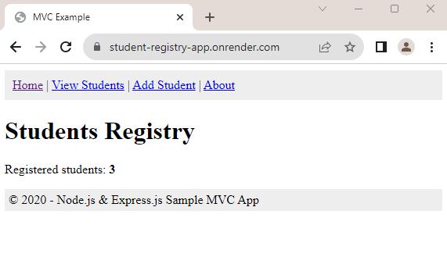

## CI/CD Workflow – "Library Catalog" App

We have the "Library Catalog" **app** in the **resources**. Your task is to **create a CI/CD workflow** in GitHub Actions to **start, test** and **deploy** the app to Render.com following the steps from the previous tasks.

